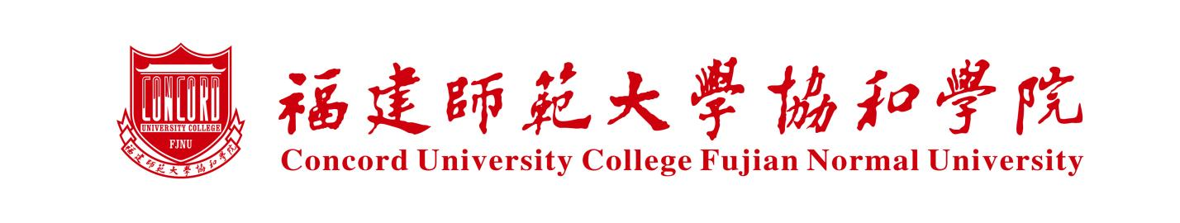

Expected Graduation Certificate

This is to certify that 姓名, 性别, ID No.：身份证号, student No.: 学生证号, has been admitted into the Program of 专业 in the Department of 系别 in 年月. He/She is a full-time undergraduate student with the schooling length of 4 years. The student will be awarded the Bachelor’s Degree of 学位upon graduation in 年月if the curriculum requirements are completed with satisfactory grades and other condition of graduation is satisfied.

Department of Academic Affairs
Concord University College, Fujian Normal University (Seal)
日期

